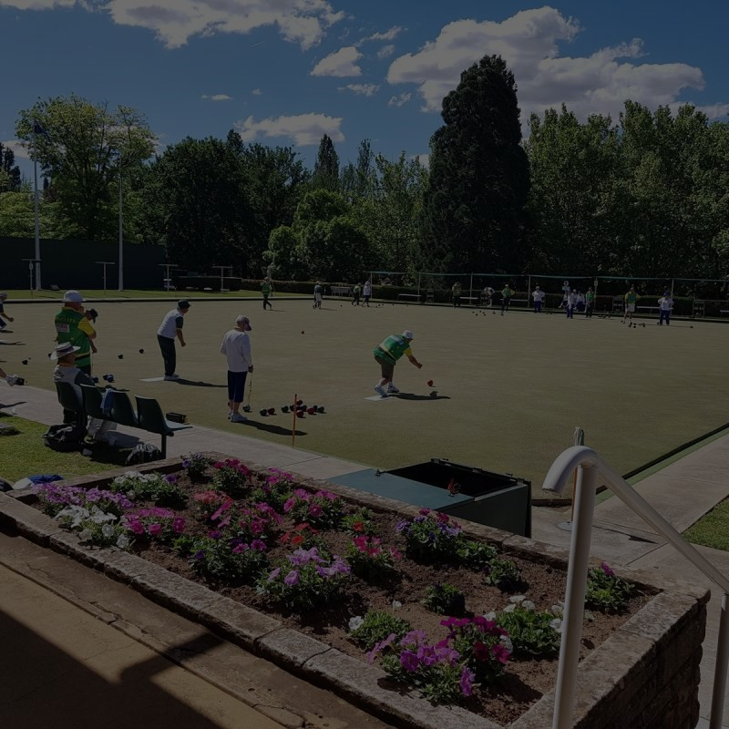
City of Orange

Golden Eagle Classic Pairs
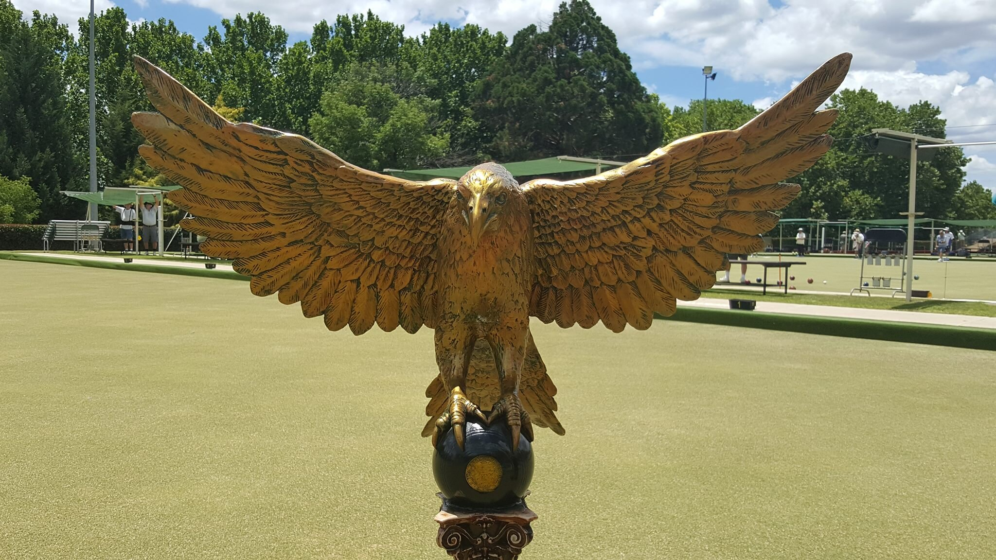

Tuesday February 28 to Friday March 3, 2023
Tournament concludes by 1pm Friday to allow players to travel home for weekend competition


MAJOR
SPONSOR

BOWLS AUSTRALIA TIER 3 RANKING EVENT
TOTAL PRIZEMONEY
$20,000
1st $5,000 Section R/Up
2nd $2,400 $250
3rd $1,700 Section 3rd Place
4th $1,500 $150
5th $1,300 Consolation
6th $1,100 1st $700
7th $1,000 Consolation
8th $ 800 $$$ for 2nd- 6th

ENTRY FEE - $300 per team
Your entry fee includes
- Lunches from Tuesday - Thursday
- BBQ at Monday night Calcutta
- Free ticket to the fully catered
Sportsman’s Night on Wednesday March 1
- $20 in Calcutta tickets

(No additional charge for wearing sponsored clothing)

The tournament is limited to 42 teams comprising of 7 sections of 6 teams playing 5 sectional rounds.

Each section winner, plus the next best performed team, will progress to the quarter-finals. All other teams will begin a three round consolation event.

Tickets will be sold for $1 each in the lead-up to the tournament
Calcutta draw Monday 27/2/23 at 6.45pm and auction to follow at 7.30pm
TOURNAMENT
CALCUTTA

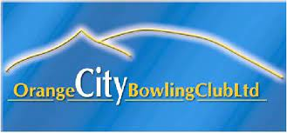
2023 GOLDEN EAGLE CLASSIC PAIRS TOURNAMENT ENTRY FORM

LEAD: _________________________ SKIP: _________________________

PH: ____________________________ CLUB: ______________________

POSTAL or EMAIL ADDRESS: ____________________________________________

Entry fee must accompany nomination – Entries Close 8/2/2023 or after 42 paid entries

FOR FURTHER INFORMATION CONTACT LEE STINSON ON 0432 823 902

ORANGE CITY BOWLING CLUB ∙ BSB: 032-833 ∙ Acc No: 700 358
PO Box 343, Orange NSW 2800 ∙ Warrendine St, Orange NSW 2800

